USDA NEWS PUBLICATION POLICY
USDA NEWS accepts ads and flyers electronically via email (usdanews@usda.org) in Microsoft word, pdf, or photo format.
Advertising rate are: Half Page $15.00, Full Page (one Side) $25.00, Full Page (2 sided flyer) $35.00. Make check payable to United Square Dancers of America. The check must be received by the publishing deadline below.

USDA NEWS is published quarterly.
Deadline dates for materials are March 1, June 1, September 1, and December 1.
If edits such the need to condense, omit, or re-write all or any part of the material the author will be notified..

USDA NEWS is not copyrighted. We welcome the reprinting of any material by USDA Affiliates, other organizations and publications. Credit line is appreciated.

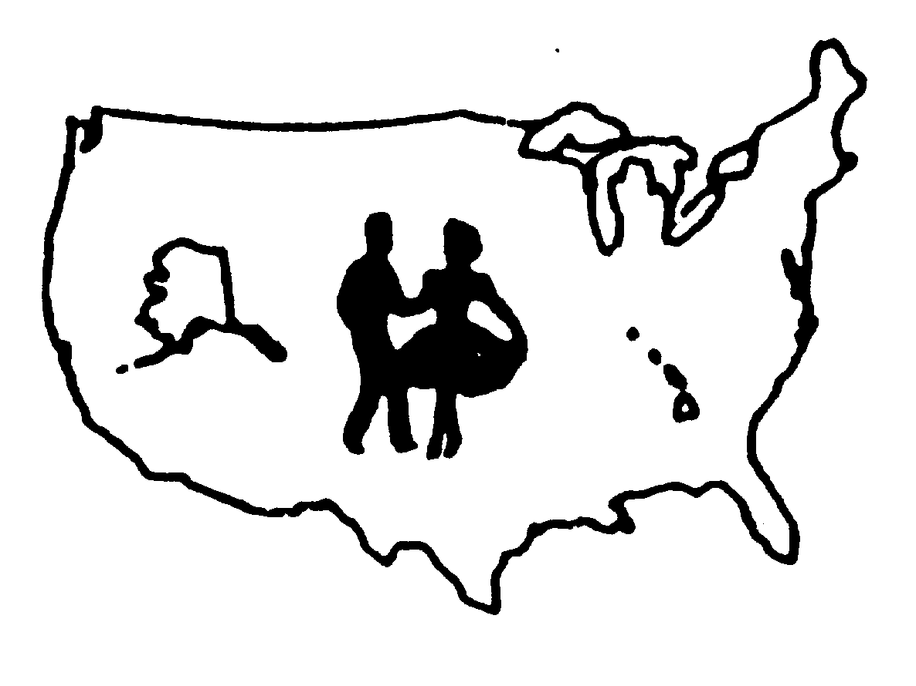
USDA NEWS

THE NATIONAL NEWSLETTER OF THE
UNITED SQUARE DANCERS OF AMERICA

The USDA NEWS publication is a quarterly publication covering all aspects of the Square Dance activity. Each issue of USDA NEWS, which averages 32-36 pages, is provided FREE to all known dance publication editors; presidents, vice presidents, delegates, and insurance representatives of state, national, and international organizations; as well as USDA Affiliates.
USDA NEWS is available to all others at a yearly subscription rate of only $6.00. The subscription rate does not pay for the newsletter but does assist in the postal costs. To keep abreast of square dance events, leadership, and education articles, and to maintain your awareness and knowledge of the total activity, you should be reading the USDA NEWS.
For your own personal copy of the quarterly USDA NEWS, complete the form below and return it with a check made out to USDA to the USDA NEWS Editor.
HAVE YOU MOVED?
Did you forget to send us a change of address? When you plan a move please send your new address as soon as possible. The post office does not forward third class mail, so don’t forget to notify us.
MAIL COMPLETED FORM TO: Lilly Hardin, PO Box 4782, Dillon, CO 80435-4782

□ I qualify for Free Subscription: (must be renewed annually)

Organization: _______________________________________ Office _______________________ □ USDA Affiliate

If publication editors, Name of Publication ___________________________Email _____________________

Please type or print clearly. Be sure the form is complete.
Attach check or money order to form for appropriate amount.

□ $6—1 Year □ $12—2 Years □ $18—3 Years

Subscription Type -- □ New □ Renewal

NAME: _______________________________________________________________________________

ADDRESS: ____________________________________________________________________________

CITY: _________________________________ STATE: _____________ ZIP: ___________ . __________
(MUST HAVE + 4 DIGITS)
PHONE: ______________________________ Email: ___________________________________________
MAIL COMPLETED FORM TO : Jim & Edythe Weber, 1316 Middlebrook Dr, Liberty, MO 64068-1941
□ I qualify for Free Subscription: (must be renewed annually)

Organization: _______________________________________ Office _______________________ □ USDA Affiliate

If publication editors, Name of Publication ___________________________Email _____________________
□ I qualify for Free Subscription: (must be renewed annually)

Organization: _______________________________________ Office _______________________ □ USDA Affiliate

If publication editors, Name of Publication ___________________________Email _____________________
USDA NEWS SUBSCRIPTIONS
SQUARE
DANCERS
INSURANCE
PROGRAM
FREE

DISCOUNT

PERSCRIPTION

CARDS

SQUARE
DANCERS
LEADERSHIP
EDUCATION
Includes All Modes
Of Square Dancing

USDA

UNITED SQUARE DANCERS OF AMERICA

THE ONLY NATIONAL DANCER’S ASSOCIATION ORGANIZED BY DANCERS FOR DANCERS AND OPERATED BY DANCERS


USDA News Editor
Email: usdanews@usda.org

For additional information about USDA or any of its programs, please visit our web site www.usda.org or Email the Education/Publications Committee at
usda.education.publications@usda.org

See web site www.usda.org Officers & Committees for Current Officers & Committee Chairs mailing address and phone.
USDA NEWS
SUBSCRIPTION
FORM

United Square Dancers of America (USDA) Publishes a quarterly news letter that contains information about dancing around the world. It keeps the dancers informed of what is going on in USDA and how it’s programs benefit dance organization, Clubs and dancers.

USDA web site at www.usda.org


Revised 7/15

