Application for Youth Grant

Name and Address of applying Organization:
…………………………………………………………………
…………………………………………………………………
USDA Affiliate: …………………………………………………………….
Date of projected need: …………………………………………………..
Please attach a one page, typed double spaced letter outlining the:
A) Need and usage of the Grant.
B) How many Youth will be impacted.
C) What has the applying organization applied towards this request.
D) Has organization requested a previous Grant (if so when and was Grant approved): ………………………………………………………
Signature(s) of Representative of Requesting Organization: …………………………………………………………………
…………………………………………………………………
Date: ………………………………………………
Phone Number(s): ……………………………….
Application and Guidelines
for the USDA
Administered Youth Grant

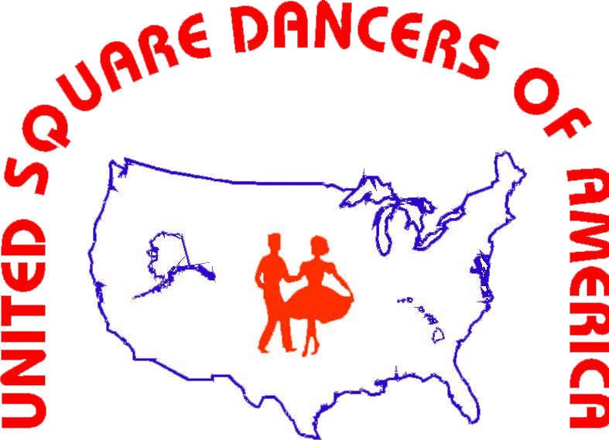

This information sheet and
application was developed by the
Youth Committee of the United
Square Dancers of America, Inc.
and will Provide a general overview
of the Grant Program and
subsequent application

IS-015
Created 07/25
Article I Standing Rules on How the Grant Program should Operate

When a club or Affiliate identifies a shortage of funds for a specific activity involving Youth. A request for a Grant to ASSIST in the shortfall should be forwarded to the USDA Youth Advisory Committee(www.Committee.usda.org) The Affiliate or Club agrees to use the funds as outlined in their request. Several examples of needs would be to help offset the costs for a group of Youth taking lessons (assisting their families), helping a group attending a State or National Convention with identified shortfalls, and help in identifying shortfalls while developing a Youth Program.

Article II Purpose

Grant was developed to Assist in the Involvement, Recruitment and Fostering of Youth Growth within the Square Dance Community. The Grant is funded by an outside source(s), but will rely on the USDA to Administer. The program will run each calendar year from January to January until all funds available are dispersed. Currently the funding is at $5,000.00 annually.

Article III Application Process

A Club or Affiliate will need to submit an application for a grant when they anticipate that they will have a shortfall financially for their Youth activity. The application once received will be reviewed and approved or denied within 30 days of receipt. The Grant is not a free pass, the requesting organization needs to show what they have done to offset the identified shortfall. The Grant funds will be dispersed in the following incremental amounts: $250.00, $500.00, $750.00 and $1,000.00 as deemed necessary, per the Grant request. Accompanying the application should be a typed double spaced one page letter, explaining the shortfall, what the requestor has done to address the shortfall, what the funds will accomplish in offsetting the shortfall and how many Youth will be positively affected. There will be only one Grant per event, however an organization can apply for, and be considered for, any other grant needs that arise.
Article IV Financials

Once a Grant is approved, funds will be issued by the USDA Treasurer to the requesting organization, via check. Requesting organization will be contacted prior to issuance for specifics on who the funds need to be directed to (ie Club/affiliate President, Treasurer etc.)

Clubs are encouraged to submit suggestions that will help with the expansion of the Grant process. Helping Youth is the primary goal. For additional information about the Grant Program or any other USDA programs please visit our website www.usda.org.

Completed Grant Applications Need to be forwarded to: www.Committee.usda.org

